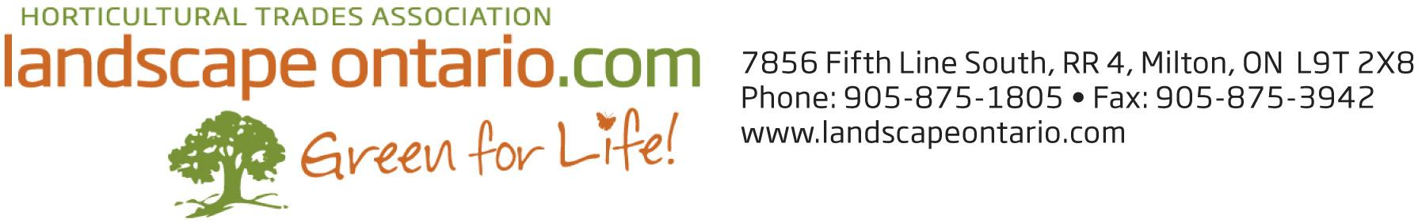
CANADA BLOOMS 2020 TICKETS
SPECIAL OFFER TO LANDSCAPE ONTARIO MEMBERS

As a member of Landscape Ontario, you can purchase special “bar-coded” tickets for the 2020 Canada Blooms/National Home Show event, March 13-22, 2020 at a discounted price

Cost of $12 per ticket (regular price $20), available as individual tickets (pay now) or packages of 20 tickets (pay per use) of which only those redeemed during the event will then be charged after the event. These packaged tickets make great gifts for clients, staff, suppliers and family members.

To order tickets, please complete this form and email it to Meghan Greaves at mgreaves@landscapeontario.com or fax to 905 875 3942.

- I would like to purchase ______ individual and pay for tickets now.

- I would like to purchase ______ pay per use tickets (multiples of 20 only).

Contact:___________________________________________________________

Company:__________________________________________________________

Address:___________________________________________________________

City:__________________________________ Postal Code: __________________

Phone #_______________________________

Email:________________________________________________________

Method of payment: ___ Visa ___ Mastercard ____ American Express

Credit Card #: _______________________________________Expiry ___________

Name on the card: _______________________________________

OFFICE USE ONLY: Ticket # from: _____________ To: ______________

Note: For those requesting packages of tickets – payment will be processed at the conclusion of Canada Blooms and include a detailed report on how many tickets were redeemed. For those purchasing individual tickets, payment will be processed at the time of purchase.

